Header **Program 1**

<html>

<head>

<title>My First Page</title>

</head>

<body>

<h1>Hello! Welcome To HTML</h1>

<h2>Hello! Welcome To HTML</h2>

<h3>Hello! Welcome To HTML</h3>

<h4>Hello! Welcome To HTML</h4>

<h5>Hello! Welcome To HTML</h5>

<h6>Hello! Welcome To HTML</h6>

</body>

</html>

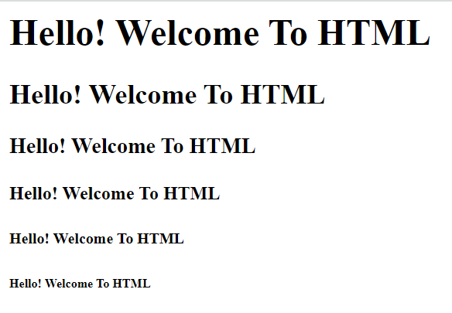

**Program 2**

***************************************************************

<html>

<head>

<title>My First Page</title>

</head>

<body>

<p>This is my First Paragraph</p>

Hello

</body>

</html>

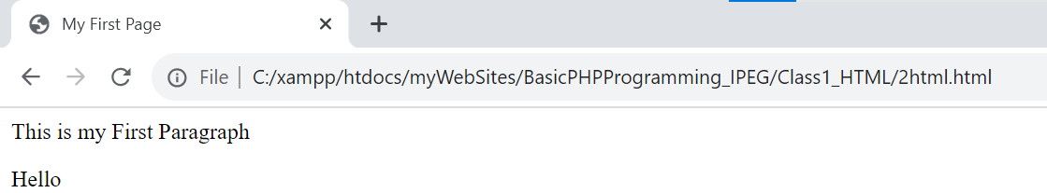

***************************************************************

**Program 3**

<html>

<head>

<title>My First Page</title>

</head>

<body>

<p>Lorem Ipsum is simply dummy text of the printing and typesetting industry. Lorem Ipsum has been the industry's standard dummy text ever since the 1500s, when an unknown printer took a galley of type and scrambled it to make a type specimen book. It has survived not only five centuries,

<h4>Bahubali:</h4>

<blockquote>but also the leap into electronic typesetting, remaining essentially unchanged. It was popularised in the 1960s </blockquote>with the release of Letraset sheets containing Lorem Ipsum passages, and more recently with desktop publishing software like Aldus PageMaker including versions of Lorem Ipsum</p>

</body>

</html>

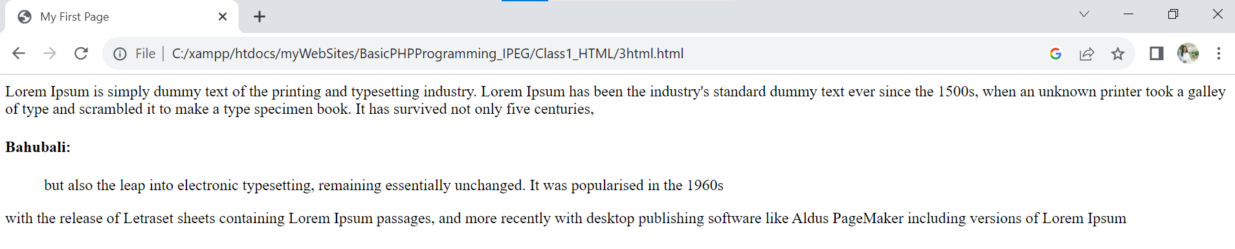

**Program 4**

<html>

<head>

<title>My First Page</title>

</head>

<body>

<p>Lorem Ipsum is simply dummy text of the printing and typesetting industry. Lorem Ipsum has been the industry's standard dummy text ever since the 1500s, when an unknown printer took a galley of type and scrambled it to make a type specimen book. <font color = "red" size = "5" face = "arial">It has survived not only five centuries</font>, but also the leap into electronic typesetting, <br>remaining essentially unchanged. It was popularised in the 1960s <strong>with</strong> the release of Letraset sheets containing Lorem Ipsum <u>passages</u>, and more recently with desktop publishing <em>software</em> like Aldus PageMaker including versions of Lorem Ipsum</p>

<hr>

</body>

</html>

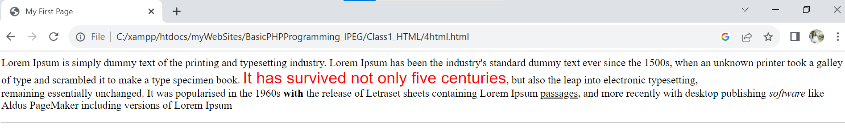

<html>

<head>

<title>My First Page</title>

</head>

<body>

<img src = "lily.jpg" width = "100"><br><br>

<img src = "./pic/game1.jpg" width = "100"><br><br>

<img src = "../img/images.jpg" width = "100"><br><br>

<img src = "C:\Users\DELL\Desktop/h1.jpg" width = "100"><br><br>

<hr>

</body>

</html>

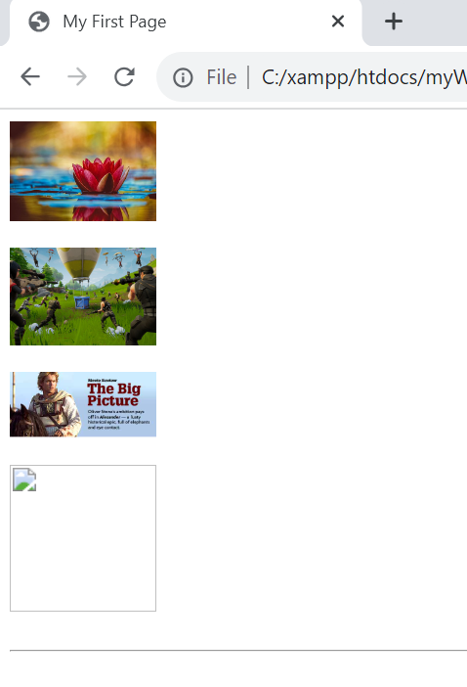

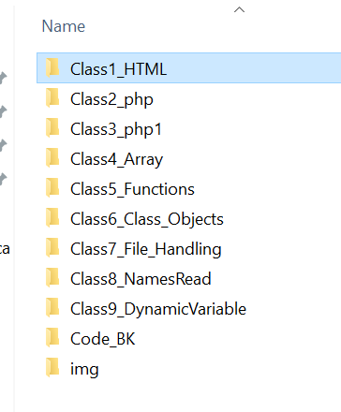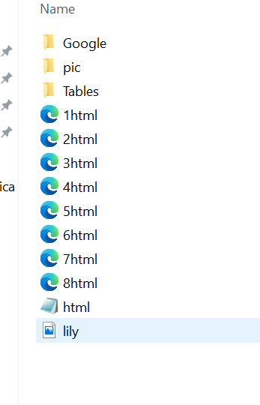

**Program 6**

<html>

<head>

<title>My First Page</title>

</head>

<body>

<a href = "http://www.google.com">Google</a><br>

<a href = "1html.html">First Page</a><br>

<a href = "2html.html" target = "_blank">New Tab</a><br>

<a href = "" >Blank</a><br>

<a href = "#" >######</a><br>

<hr>

</body>

</html>

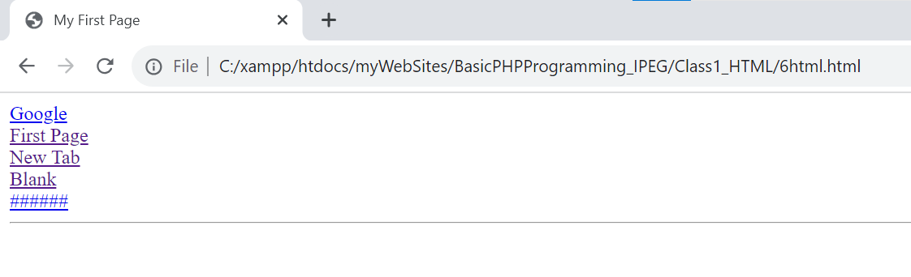

**Program 7**

<html>

<head>

<title>My First Page</title>

</head>

<body>

<form>

<input type = "text" placeholder = "Enter Your Name"><br>

<input type = "number" placeholder = "Enter Your Number"><br>

<input type = "submit" value = "Register">

</form>

<a href = "">Blank</a>&nbsp;&nbsp;&nbsp;

<a href = "#">####</a>

<hr>

</body>

</html>

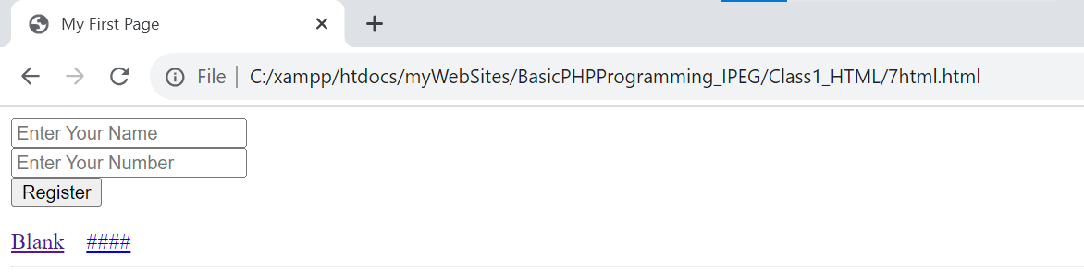

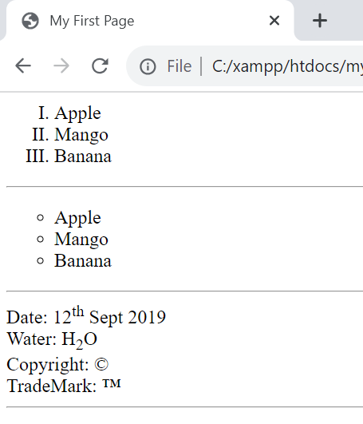**Program 8**

<html>

<head>

<title>My First Page</title>

</head>

<body>

<!-- Ordered List type = 1,I,i,A,a -->

<ol type ="I">

<li>Apple</li>

<li>Mango</li>

<li>Banana</li>

</ol>

<hr>

 <!-- Unordered List type = disc(D),square,circle -->

<ul type = "circle">

<li>Apple</li>

<li>Mango</li>

<li>Banana</li>

</ul>

<hr>

Date: 12<sup>th</sup> Sept 2019<br>

Water: H<sub>2</sub>O

<br>

Copyright: &copy;<br>

TradeMark: &trade;

<hr>

</body>

</html>

**Program 9**

<html>

<body>

<table border = "1" height = "200" width = "300" align = "center">

<tr>

<td>1</td>

<td>2</td>

<td>3</td>

<td>4</td>

</tr>

<tr>

<td>5</td>

<td>6</td>

<td>7</td>

<td>8</td>

</tr>

<tr>

<td>9</td>

<td>10</td>

<td>11</td>

<td>12</td>

</tr>

</table>

</body>

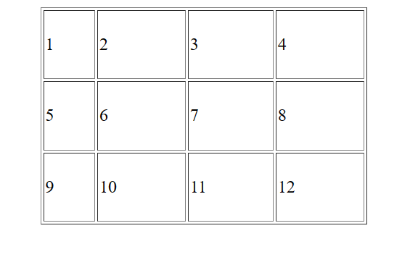</html>

**Program 10**

<html>

<body>

<table border = "1" height = "200" width = "300" align = "center" cellspacing = "20" cellpadding = "10">

<tr>

<td>1</td>

<td>2</td>

<td>3</td>

<td>4</td>

</tr>

<tr>

<td>5</td>

<td>6</td>

<td>7</td>

<td>8</td>

</tr>

<tr>

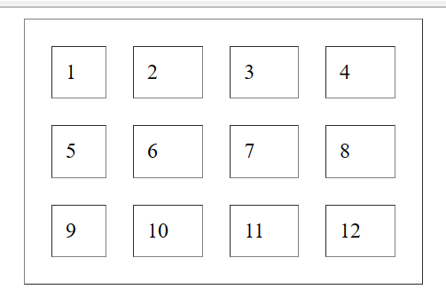 <td>9</td>

<td>10</td>

<td>11</td>

<td>12</td>

</tr>

</table>

</body>

</html>

**Program 11**

<html>

<body>

<!-- align = left,right,center

valign = top,bottom,middle

-->

<table border = "1" height = "200" width = "300" align = "center" cellspacing = "0" >

<tr>

<td align = "center">1</td>

<td align = "right">2</td>

<td valign = "top">3</td>

<td>4</td>

</tr>

<tr>

<td align="right" valign = "top">5</td>

<td align = "center" valign = "bottom">6</td>

<td>7</td>

<td>8</td>

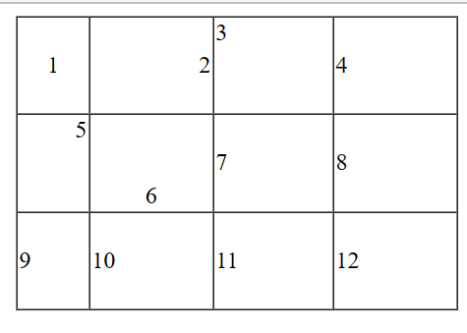 </tr>

<tr>

<td>9</td>

<td>10</td>

<td>11</td>

<td>12</td>

</tr>

</table>

</body>

</html>

**Program 12**

<html>

<body>

<table border = "1" height = "200" width = "300" align = "center" cellspacing = "0" >

<tr>

<td colspan = "2">1</td>

<td>3</td>

<td>4</td>

</tr>

<tr>

<td>5</td>

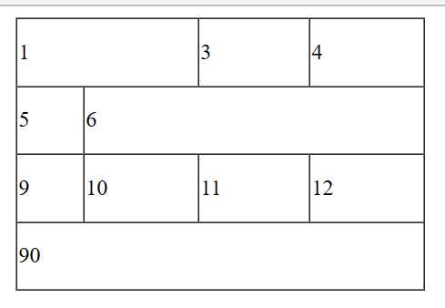 <td colspan = "3">6</td>

</tr>

<tr>

<td>9</td>

<td>10</td>

<td>11</td>

<td>12</td>

</tr>

<tr>

<td colspan = "4">90</td>

</tr>

</table>

</body>

</html>

**Program 13**

<html>

<body>

<table border = "1" height = "200" width = "300" align = "center" cellspacing = "0" >

<tr>

<td rowspan = "2">1</td>

<td>2</td>

<td>3</td>

<td>4</td>

</tr>

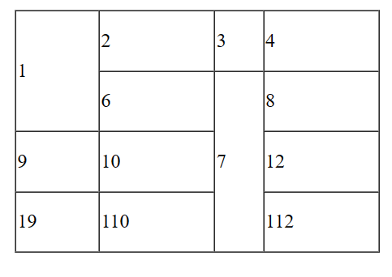 <tr>

<td>6</td>

<td rowspan = "3">7</td>

<td>8</td>

</tr>

<tr>

<td>9</td>

<td>10</td>

<td>12</td>

</tr>

<tr>

<td>19</td>

<td>110</td>

<td>112</td>

</tr>

</table>

</body>

</html>

**Program 14**

<html>

<body>

<table border = "1" height = "200" width = "300" align = "center" cellspacing = "0" cellpadding = "10">

<tr>

<td colspan = "2">1</td>

<td>1</td>

<td>1</td>

<td>1</td>

</tr>

<tr>

<td rowspan = "3">1</td>

<td colspan = "3">1</td>

<td>1</td>

</tr>

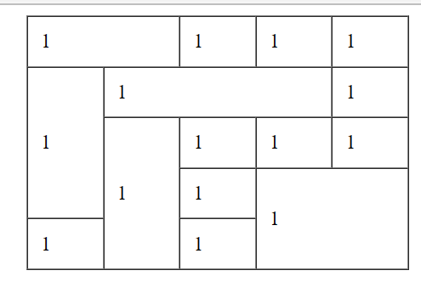 <tr>

<td rowspan = "3">1</td>

<td>1</td>

<td>1</td>

<td>1</td>

</tr>

<tr>

<td>1</td>

<td colspan = "2" rowspan = "2">1</td>

</tr>

<tr>

<td>1</td>

<td>1</td>

</tr>

</table>

</body>

</html>

**Program 15**

<table border="1" height="500" width="500">

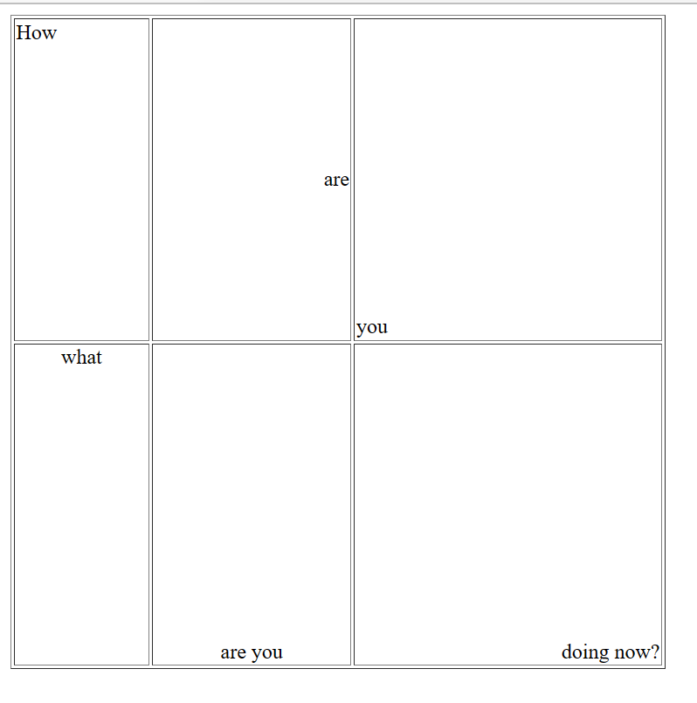<tr>

<td align="left" valign = "top">How</td>

<td align="right" valign = "middle" >are</td>

<td align="" valign = "bottom">you</td>

</tr>

<tr>

<td valign="top" align="middle">what</td>

<td valign="bottom" align="middle">are you</td>

<td align="right" valign="bottom">doing now?</td>

</tr>

</table>

What is HTML?

Hypertext Markup Language is the standard markup language for creating web pages.

Hypertext means machine readable text and Markup means to structure it in a specific format.So,HTML is called hypertext markup language because it is a language that allows users to organize, improve the appearance of, and link text with data on the internet.